Wasatch Commons Tree Trimming and Removal Initiative

Introduction
In November 2020, the Wasatch Commons Cohousing (WaCoHo) Landscape Committee started the process of documenting trees in need of trimming or removal within the community’s property. The effort included consulting with community members in-person, via Zoom meetings and an online survey. Committee members met regularly to discuss tree selection criteria and meet with various local arborists referred to us by community members. The Landscape Committee meetings were open to all members of the community.
We envision this effort to be accomplished using a multi-phased approach due to budget constraints and to avoid the pruning and removal of too many trees at one time. This will allow for more desired trees to be put in place as others are removed without depleting all the allocated dollars for the landscape committee at any given year. The Landscape Committee opted for a scoring approach to determine which trees to be trimmed and removed first as seen on section 2 below.
This is not an all-encompassing evaluation of every tree in the community. For this first assessment, we selected trees based on resident input and perceived threat to safety of structures and community members. This initiative should be updated every calendar year to ensure trees continue to be assessed, scored, and pruned/removed as needed.

1.1 Landscape Committee Members - November 2020
- Emilie Jordao – Convener
- Alexandra Parvaz – Head of Tree Trimming and Removal Initiative
- Kelly Henderson – Member
- Lila Sweeney – Member
- Joe Sweeney - Member
- Kierstin O'Flaherty – Member
- Amy May – Member
- Cheryl Keil – Member
- KJ Finney – Member
- Mary English – Member
- Maxine Hanks – Member

1.2 Arborists Consulted
Alex met individually with the following consultants to determine cost, availability, and expertise to perform the pruning and removal work at Wasatch Commons.
- Arbor Concepts
- Amen Trees
- Diamond Tree Experts

1.3 Tree Work Terms
- Pruning
Technique that might include deadwooding, weight or canopy reduction.
- Deadwooding
Pruning process of removing dead limbs from the tree that might be dangerous, diseased or targets of pest infestation.
- Weight Reduction
Pruning technique that involves the gentle reduction of lateral branches on a tree. By reducing your tree's spread through selective branch removal, you are maintaining its good health, natural form and structural integrity.
- Canopy Reduction
Canopy reduction removes branches and stems from the outer portion of the canopy back to lateral branches at least one-third the diameter of the removed stems or branches.
- Removal
Complete removal of a tree that can be accomplished with a series of methods, including removal with the assistance of a crane.
- Remove and Prune Mixed Approach
Some trees grow in clumps which can cause rotting and present a safety hazard. A “remove and prune mixed approach” means that one or more trees in the clump will be removed while the remaining ones will be pruned for safety.

2. Initial Assessment

2.1 Trees Assessed
Overall, 22 individual trees/tree groups were assessed between November and December 2020. These are shown on Figure 1.
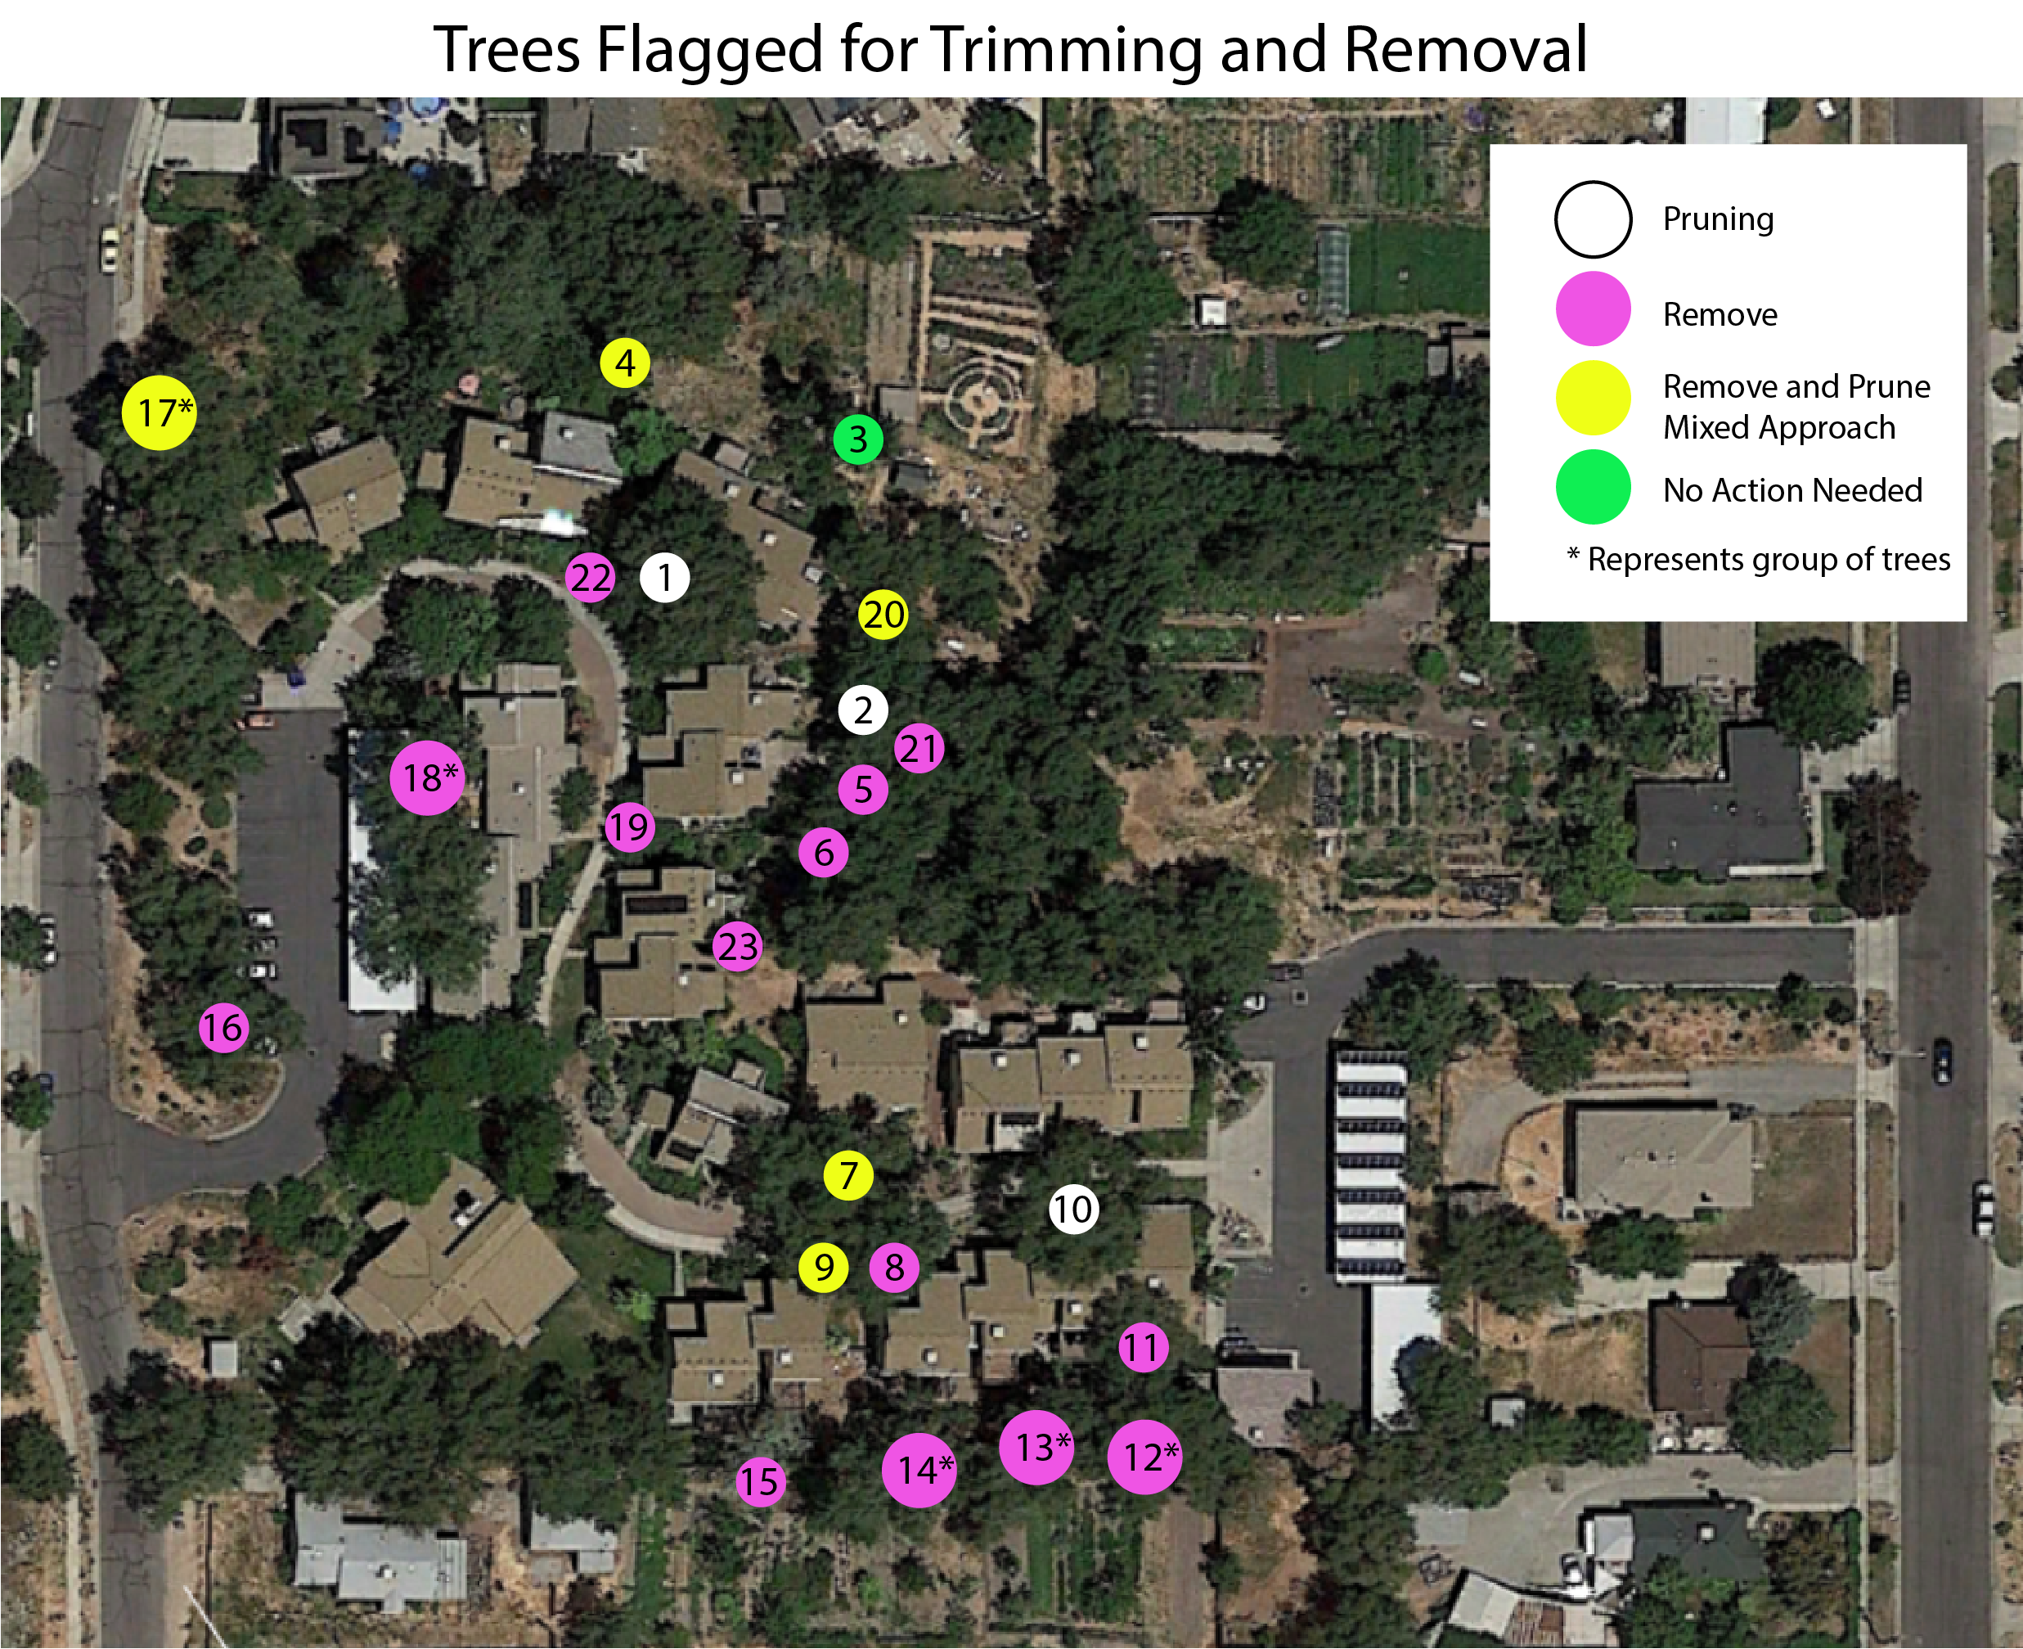
Figure 1. Individual trees (white) and tree groups (yellow) assessed in fallBi and winter 2020.

2.1 Individual Tree and Tree Groups Description
Descriptions were crafted after the evaluation from tree experts mentioned on section 1.2.
- American elm, Ulmus americana - Prune
Tree appears healthy but there are signs of rotting on its north side. Arborists agree this is a beautiful specimen. There is a need for pruning branches that are too close to Units 5 and 6.

- Siberian elm, Ulmus pumila – Remove and Prune Mixed Approach
This tree clump has severe trunk decay which poses a risk to nearby landscaping on Unit 7 and community path which has lots of foot traffic, including children and elderly. The risk of tree or branch fall is increased during snow and windstorms.

- Russian olive, Elaeagnus angustifolia – No Action Required
Although this tree species is generally not desired one for its ability to spread, this specimen seems contained and healthy. It also is not diseased and does not seem to pose a risk to safety.
- Siberian elm, Ulmus pumila - Prune
This clump of Siberian elms west of the duck pen could use deadwooding and weight reduction on branches closest to Unit 4.

- Siberian elm, Ulmus pumila - Remove
This tree has an unusual shape and hangs over the back area of Unit 9. It does not appear to be heavy and might not be a particular threat now. No decay or disease visible.

- Siberian elm, Ulmus pumila - Remove
This Siberian elm clump could use the removal of the center trunk, as well as weight reduction of canopy since lots of branches are close to Units 9 and 11.

- Siberian elm, Ulmus pumila - Remove
This Siberian elm clump could use the removal of the center trunk, as well as weight reduction of canopy since lots of branches are close/hanging over to Units 15, 17 and 19.

- Siberian elm, Ulmus parvifolia - Remove
This tree is too close to Unit 20 which poses risks to the house.

- Siberian elm, Ulmus pumila – Remove and Prune Mixed Approach
This Siberian elm clump could use the removal of the center trunk, as well as weight reduction of canopy since lots of branches are close/hanging over to Units 18.
- Siberian elm, Ulmus pumila - Prune
This tree bears a lot of canopy weight on top of Units 23 and 25. Arborists suggest weight reduction over the house and lowest tree lead.
- Siberian elm, Ulmus pumila - Remove
This tree is too close to Unit 25. Canopy weight reduction might be enough to resolve the issue.

- Siberian elm, Ulmus pumila – Remove
This is a group of 3+ trees on the back of Unit 25 and neighbors the parcel to the south. Branches are hanging over neighboring property and pose a risk to their structures (i.e. hoop houses). Removal or pruning (or a combination) are feasible options.

- Siberian elm, Ulmus pumila - Remove
This is a group of 3+ trees on the back of Unit 21 and neighbors the parcel to the south. Branches are hanging over neighboring property.

- Siberian elm, Ulmus pumila - Remove
This is a group of 3+ trees on the back of Unit 20 that poses a risk to their house as well as chicken coop on neighbor’s property.

- Russian olive, Elaeagnus angustifolia – Ask Resident
This tree poses some risk to Unit 18. Pruning could resolve the issue since it seems otherwise healthy. Need to consult resident in regards to preference between pruning or removal.

- Siberian elm, Ulmus pumila - Remove
This tree overhangs a few parking stalls in the Utah St parking lot and poses threat to parked cars. Arborists suggest complete removal.
- Siberian elm, Ulmus pumila – Remove and Prune Mixed Approach
There are 2 stands of Siberian elm comprising 7-8 trees with branches overhanging the street. Since these trees are located within public ROW, they might be trimmed by the city, or at least some cost can be shared. Alex will check with the city.

- Siberian elm, Ulmus pumila - Remove
This is a group of 3 Siberian elms on the back of Unit 10, branches overhang the house and carport. One of the trees lost a branch on a recent windstorm which could happen again in the future. Residents of Unit 8 report a significant number of bugs on the trees that get inside the houses year-round.
- Crabapple, Malus sp. - Remove
This small tree between Units 9 and 11 poses little safety risk but is a nuisance. The branches overhang the walkway when not pruned since it is a weeping variety and fruits litter the common path during summer and fall.
- Siberian elm, Ulmus pumila - Remove and Prune Mixed Approach
Clump of 3 Siberian elm trees located in the meditation spiral and back of Unit 6 which poses risk to the pathway and house. Removal of the lead closest to the house is proposed as well as additional canopy trimming.

- Siberian elm, Ulmus pumila - Remove
Small, young elm clump near #5. Easy removal that would solve canopy crowding issues.

- Crabapple, Malus sp. - Remove
Small tree in front of Unit 5. It is almost completely dead although does not represent significant safety risks.

- Siberian elm, Ulmus pumila - Remove
Small, young tree behind #13, it is currently too close to the unit.

Previous Efforts
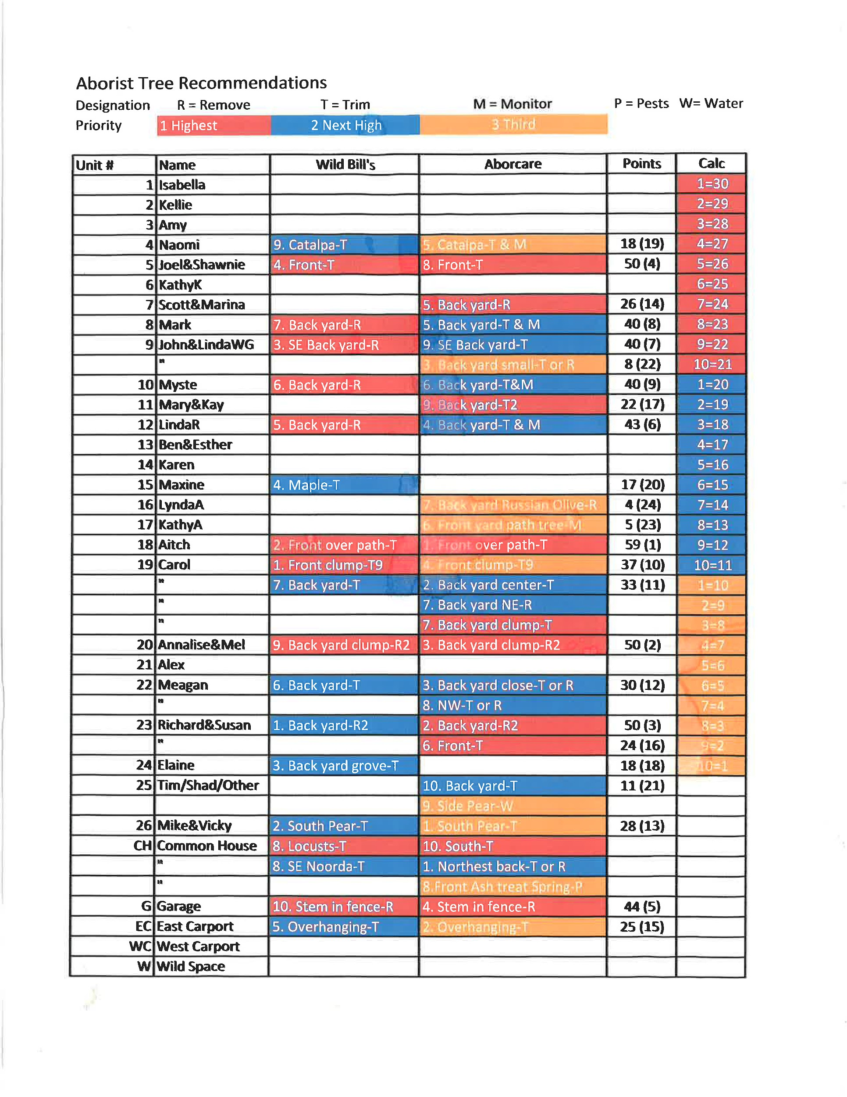

Scoring Criteria
See criteria listed below followed by their respective weights. In short, safety threat and neighbor/community support are the most important criteria, therefore have double weight when compared to all other categories.
- Safety Threat (2)
Trees that represent a safety threat are usually hanging on top of structures (i.e. houses, carport, etc.) or pathways.
Points | Description
0 | No risk to safety of residents and structures
10 | Moderate risk to safety of residents and structures
20 | High risk to safety of residents and structures

- Immediate Neighbor or Community Support (2)
Support for pruning and removal by immediate neighbors is of ultimate importance for this process. We gathered feedback from residents immediately adjacent to trees to accurately provide this score. In cases where the trees are located away from any units (i.e parking lot), the whole community was polled via an online survey.
Points | Description
0 | No support from neighbors or community
10 | Moderate support of neighbors or community
20 | Heavy support of neighbors or community
- Tree Species (1)
Preference for removal is given to trees that are invasive to Utah.
Points | Description
0 | Native species
5 | Non-invasive non-native species, includes ornamentals
10 | Invasive species

- Tree Health (1)
Trees that are diseased or dead have preference on pruning/removal since they impose higher safety risk and might spread pathogens to healthy trees.
Points | Description
0 | Tree is healthy
5 | Tree is moderately diseased or rotted
10 | Tree is heavily diseased, rotted, or dead

- Tree Function (1)
Trees that are not performing their function, or that are a nuisance, have preference to be pruned or removed. For example, trees obstructing or littering walking paths are considered dysfunctional.
Points | Description
0 | Tree is performing its function
5 | Tree is moderately performing its function
10 | Tree is dysfunctional

- Distance to other trees in need of work (1)
Trees that are located near other trees or tree groups in need of work are considered most cost-effective for pruning or removal and score higher in this
Points | Description
0 | Tree is far away from other trees to be pruned/removed
5 | Tree is somewhat near to other trees to be pruned/removed
10 | Tree is adjacent to other trees to be pruned/removed

- Access (1)
Trees that are easy to access score higher in this category.
Points | Description
0 | Tree is difficult to access
5 | Tree access is of moderate difficulty
10 | Tree is easy to access

Summary of Community Comments:

Between January 24-February 7, 2021, Emilie Jordao and Alexandra Parvaz interviewed units 1-26 for feedback regarding the report and their preferred maintenance of trees nearest their units and others that concerned them.
Additionally, Alexandra addressed the price range of the bids from $20k-26k and of our intention to put up for discussion whether all units would be willing to pay an extra one-time payment of $500 to cushion the original limited budget and cover all projected expenses if all tree work were completed in the 2021 year. This idea was not discussed with residents of Units 1-17 one-on-one since it was created after the first rounds of interviews. All residents will be informed of all options at ACMs or individually when they are officially drafted.
Below are summaries of their comments:
- Unit 1/ Izzy: Izzy supports the landscape committee efforts.
- Unit 2/ Kellie: Kellie supports the landscape committee efforts. She only asks for sufficient notice before the tree next to the duck pen gets trimmed, so she can move them.
- Unit 3/ Amy: Amy supports the landscape committee efforts.
- Unit 4/ Naomi: Naomi doesn't want the Catalpa next to her house trimmed. She supports trimming of tree #4 for safety reasons.
- Unit 5/ Kierstin: Kierstin supports the landscape committee efforts.
- Unit 6/ Victor: Victor supports the landscape committee efforts, he leans towards a more minimalistic approach when it comes to pruning and removing trees.
- Unit 7/ Marina: Marina supports our efforts, she is happy the tree on her yard can be salvaged and pruned as needed. She appreciates notices to avoid any tree surprises. She opposed the removal of tree #19.
- Unit 8/ Lila: Lila wants to see the trees behind unit 10 gone because branches fell during the windstorm in Fall 2020. It also causes bug infestations in her unit.
- Unit 9/ Emilie: Emilie is organizing the effort and agrees with all tree trimming and removals proposed here.
- Unit 10/ KJ: KJ owns the unit, and Amy communicated to the landscape committee that KJ supports the removal of the trees behind Unit 10.
- Unit 11/ Mary: Mary supports the removal and trimming of trees that pose safety and other risks to the community.
- Unit 12/ Linda: Linda supports the landscape committee efforts.
- Unit 13/ Ben: Ben supports the landscape committee efforts. He suggested a tree really close to the back of his unity be removed due to proximity.
- Unit 14/ Laraine: Laraine supports the landscape committee efforts. She mentioned the siberian elms behind her unit overhangs her vents, dropping seeds and causing bug infestation in her unit.
- Unit 15/ Maxine: Maxine supports the landscape committee efforts.She likes 2 of the 3 leads in the clump in front of Carol's home, it provides shade her unit. Double-check with arborists which lead will be removed, and try to preserve the ones she enjoys for shade if possible.
- Unit 16/ Lynda: Lynda supports the landscape committee efforts.She would like to see the tree behind Cheryl's unit removed rather than trimmed but said to ask Cheryl about her opinion.
- Unit 17/ Kathy: Feedback needed
- Unit 18/ Cheryl: In support of report suggestions, fulfilling all measures this year and of the complete removal of trees 8 and 9. She defers to Linda Angelastro regarding whether to remove or prune the Russian Olive tree in her backyard. She also defers to Linda whether she may want to keep at least the cluster of Mullberry saplings in her backyard, however, it would need to be pruned and some She supported the option of paying the one-time additional $500 fee to get the entire report findings completed in the year.
- Unit 19 Carol: In favor of launching more aggressive tree maintenance measures and approves of having two among a cluster of three trees nearest her house fully removed. She would consent to have at least the central tree in this cluster excised and the other suspect and tagged tree be pruned and dead branches removed. The other trees further south and in front of her unit she approves having canopy weight reduction and any other efforts to ensure longer-term health of the trees. She agreed to consider the option of paying the one-time additional $500 fee to get the entire report findings completed in the year.
- Unit 21/ Diana: In support of the all suggested pruning and tree removal measures. She questions who bears responsibility for the hazardous cluster of trees to the south of her backyard and on the opposite side of a temporary fence that Shad installed. Whoever is accountable should then pay for their maintenance.
- Unit 22/ Meagan: Approves of the report finding and maintenance measures. Regarding tree clusters 8 and 9, she expressed desire for fruiting perennial bushes and combination of colorful intentional plantings and trellised vining plants to recreate a faster-growing, living shade structure position over the pathway.
- Unit 23/ Susan: In support of the proposed pruning and removal options. Would like to see the large Siberian Elm tree nearest her house pruned and for all the branches bowing over her roof removed. She is also concerned about this tree’s rooting system which has effectively intertwined with a sewage line and a few years ago had to pay heavily for the removal of the interfering roots. Their plumber warned that as long as the tree remains, the problem will repeat, and will need to remove them again after a few more years. She approves of the removal and/or canopy weight reduction of the trees in her backyard. She supports considering the option of paying the one-time additional $500 fee to get the entire report findings completed in the year.
- Unit 24/ Beth: In support of wacoho committing this year to fully completing the itemized task list of pruning and removal of risk-prone trees and getting done with the measures rather than prolonging action. Doing so would avoid accumulating maintenance costs and enhancing liability risks of Subrogation negligence. Argues that over the past 20 years, each year we gained $1,500 in maintenance fees and points that the current budget dismisses the urgency of necessary tree management. She stressed her concern of the Siberian elm species as multiply problematic given their propensity to be pest and pathogen-prone and to have severely weak limbs so that they shed substantial branches and require significant clean-up and management. Further, they carry significant liability to human life and property damage. She strongly recommends that all Wacoho trees be relabeled and considered as INFRASTRUCTURE, given their capacity to cause harm to all wacoho- owned structures. Relabeling as such may then impress further urgency to tree maintenance and vindicate increasing the annual budget ascribed to this field. She strongly prefers trees native to Utah and that are drought resistant and productive.
- Unit 25/ Lauren: In full support of the findings and bring to fruition all pruning measures this year. She prefers that all Siberian elms in her backyard be removed, however, should the community restrict the budget in favor of a gradual tree reduction approach, she asks that the tree closest to her house be entirely removed and that the trees nearest the Southend of her fence be heavily pruned and have canopy reduction. She supported the option of paying the one-time additional $500 fee to get the entire report findings completed in the year.
- Unit 26/Vicky and Mike: In support of pruning, and if the community approves, the removal of risk-identified/risk-prone trees. They stress, though that with any tree removal, there also be plans for replacing these exited trees with healthier more climate adaptable and sturdy varieties. . They deeply revere the trees in especially at the east entrance which they praise as community gathering spaces under their shade. they would be sad to see the cluster of trees between Cheryl and Alex’s units go, however, understand that in their stead are possibilities for alternative, healthier and less liability prone plantings.

Scoring Table
Table 1. Tree Scoring (average=67). In dark red = trees with highest scores, in light red = trees adjacent to highest scoring trees that have scores above the average.
Tree # | Safety Threat | Neighbor/Community Support | Species | Health | Function | Distance | Access | Total
1 | 20 | 20 | 5 | 10 | 0 | 10 | 10 | 75
2 | 20 | 20 | 10 | 10 | 0 | 10 | 10 | 80
3 | 0 | 10 | 10 | 0 | 5 | 0 | 5 | 30
4 | 10 | 20 | 10 | 5 | 0 | 0 | 0 | 45
5 | 10 | 20 | 10 | 0 | 0 | 10 | 5 | 55
6 | 10 | 20 | 10 | 5 | 5 | 10 | 5 | 65
7 | 10 | 20 | 10 | 5 | 10 | 10 | 10 | 75
8 | 20 | 20 | 10 | 0 | 10 | 10 | 10 | 80
9 | 10 | 20 | 10 | 0 | 10 | 10 | 10 | 70
10 | 20 | 20 | 10 | 0 | 0 | 10 | 10 | 70
11 | 20 | 20 | 10 | 5 | 10 | 10 | 5 | 80
12 | 20 | 20 | 10 | 5 | 10 | 10 | 5 | 80
13 | 10 | 20 | 10 | 5 | 10 | 10 | 5 | 70
14 | 10 | 20 | 10 | 5 | 10 | 10 | 5 | 70
15 | 0 | 20 | 10 | 5 | 10 | 10 | 5 | 60
16 | 20 | 10 | 10 | 0 | 0 | 5 | 10 | 55
17 | 20 | 10 | 10 | 10 | 0 | 5 | 10 | 65
18 | 20 | 20 | 10 | 5 | 10 | 10 | 0 | 75
19 | 0 | 10 | 5 | 0 | 10 | 0 | 10 | 35
20 | 20 | 20 | 10 | 0 | 5 | 10 | 10 | 75
21 | 0 | 20 | 10 | 0 | 10 | 10 | 5 | 55
22 | 0 | 20 | 5 | 10 | 0 | 10 | 10 | 55
23 | 10 | 20 | 10 | 0 | 10 | 10 | 5 | 65

Phasing

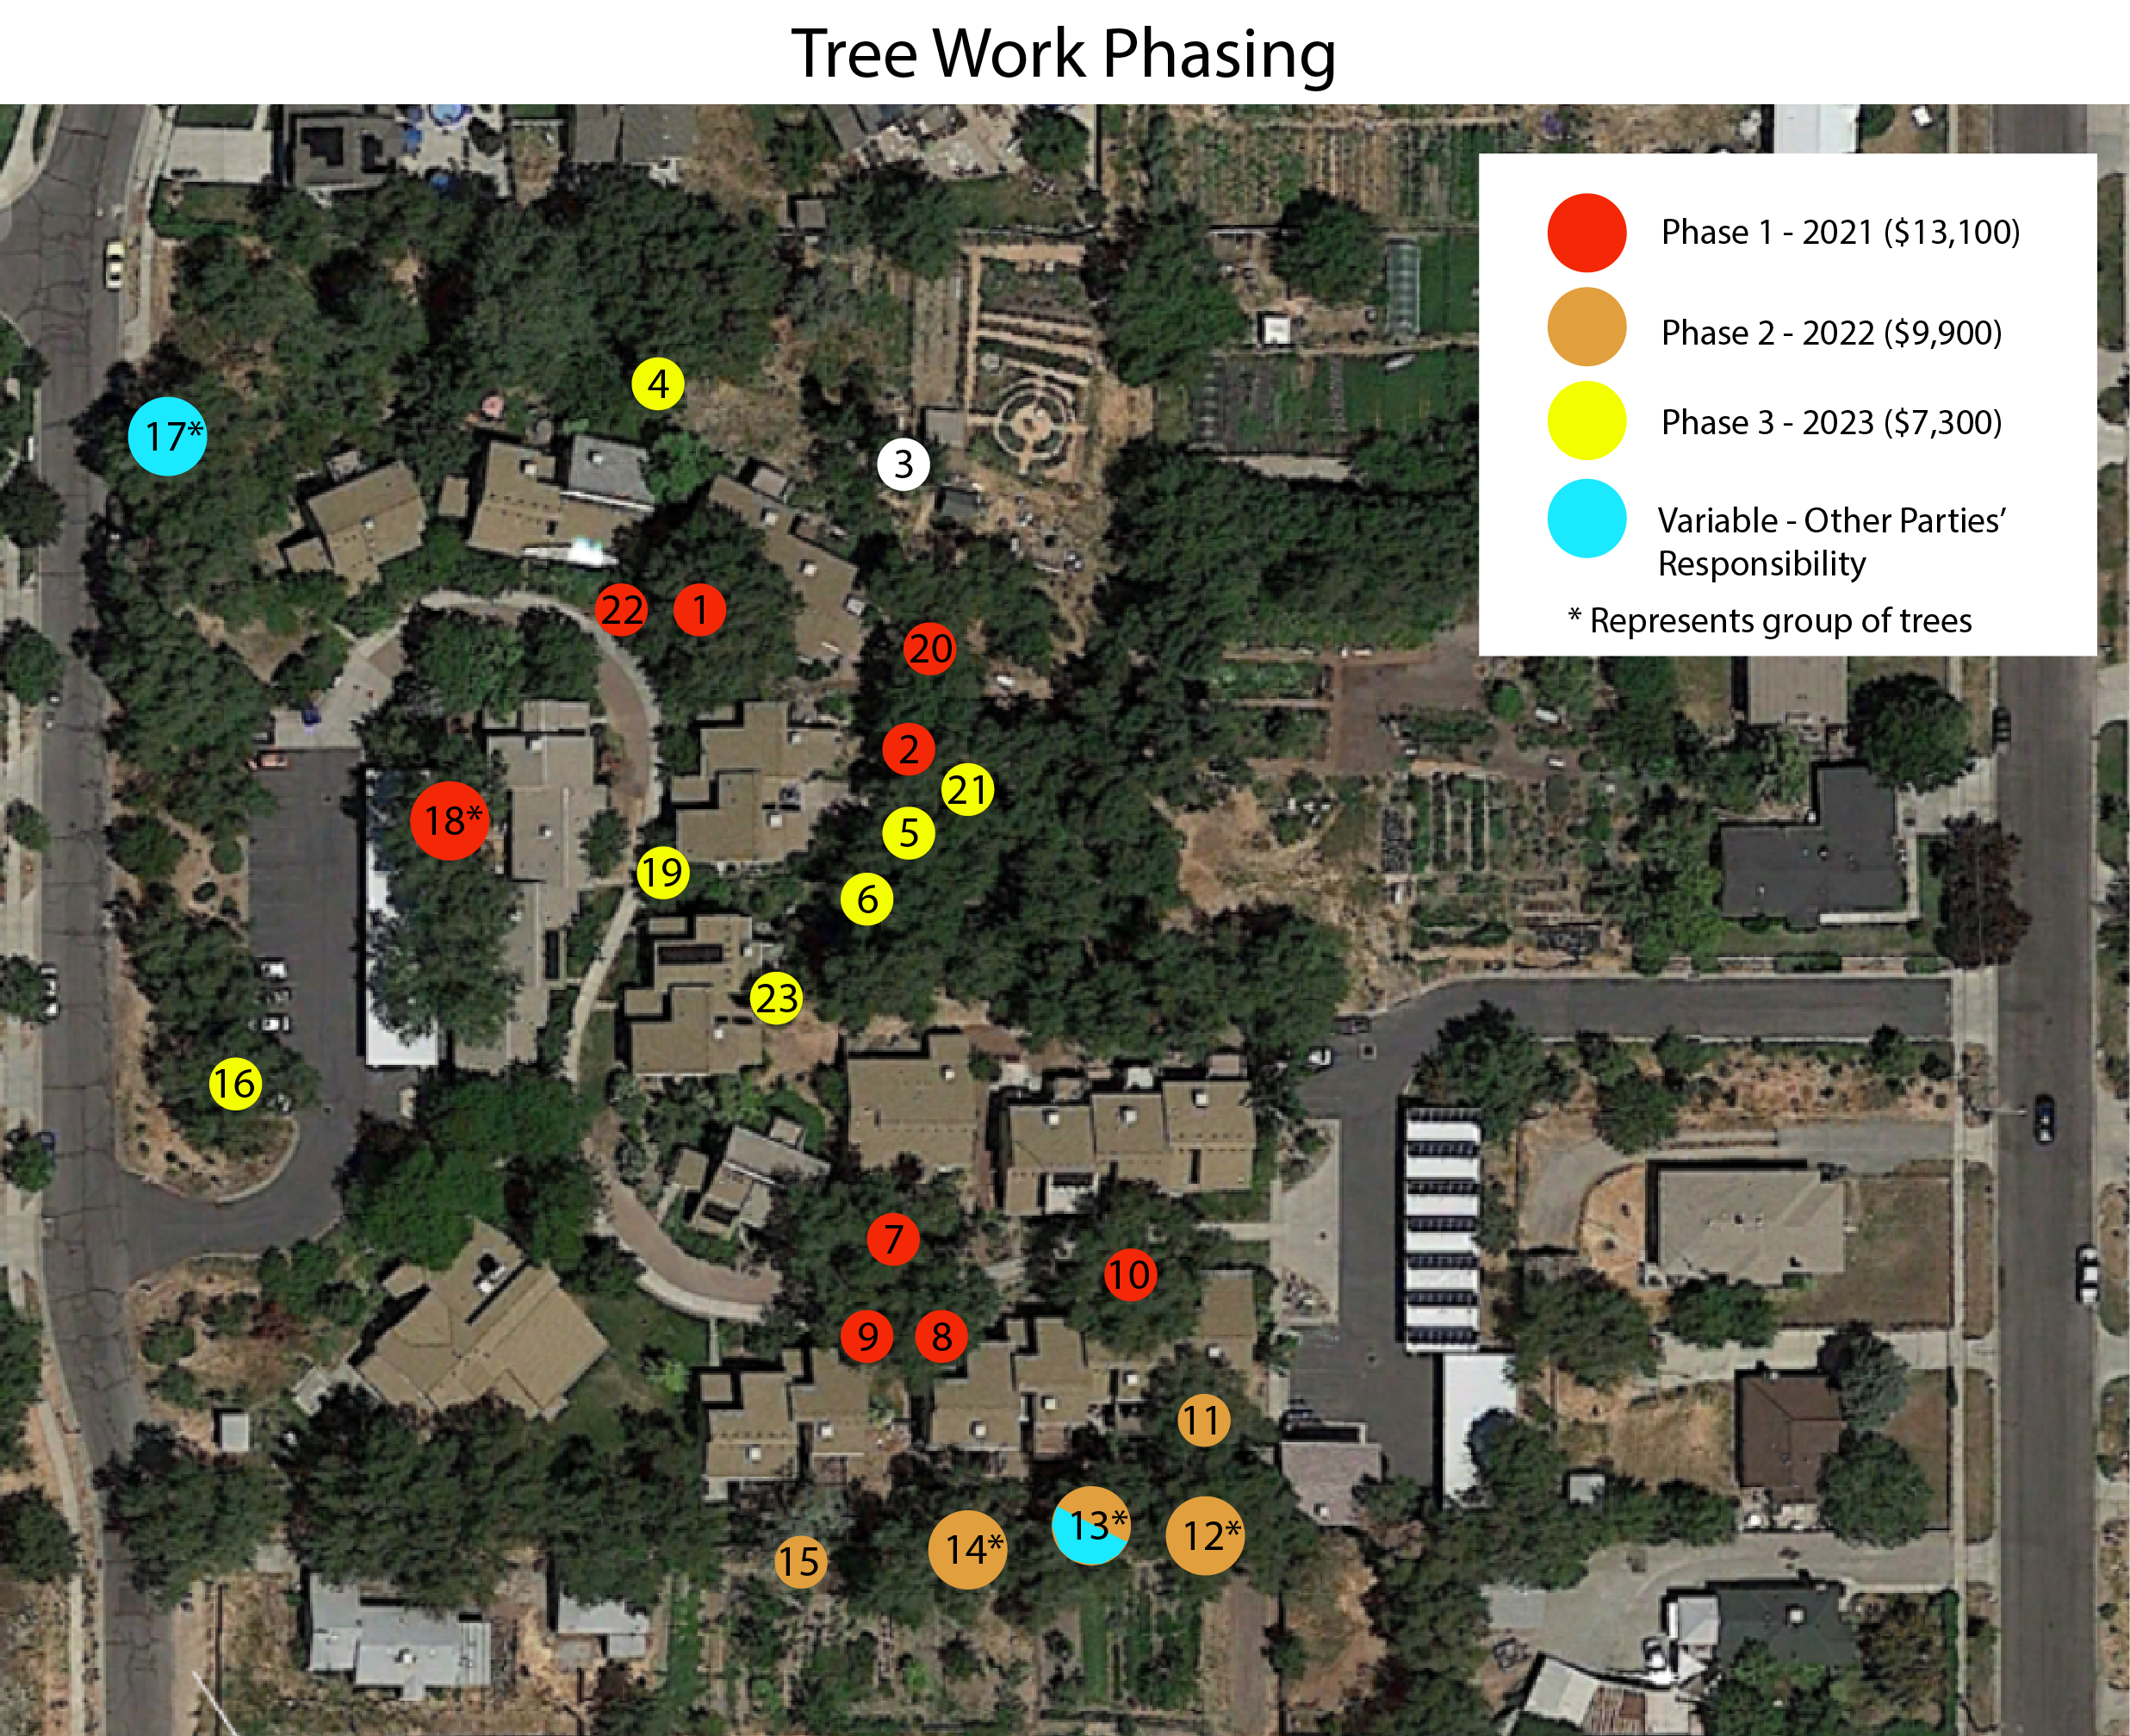

Landscape Committee 2021 - Budget Breakdown
Total budget: $18,500*
*$8,500 (initial) + $10,000 (additional amount set by management)
- Tree trimming - Phase 1. Total = $13,100
  - Tree #1- Full structure prune ($900)
  - Tree #2- Full structure prune ($600)
  - Tree #20- Structure prune reduce lead with decay ($600)
  - Tree #22- Remove dead crab apple, to be done by community members
  - Tree #10- Canopy reduction ($1800)
  - Trees #7,9,8- Remove two East elms in 7 and lead over house in 9 and remove elm 8. ($3800)
  - Tree #18- Remove all elms to ground level ($5400)
- Tree Planting. ($1,000)
- Irrigation ($500)
- Xeriscaping Project ($150)
- Other - contingency ($1,000)
  - Total Combined = $2,650
- Remaining to be applied towards Phase 2 = $2,750
- Amount needed to complete Phase 2 = $7,150

Upcoming Years - Tree Trimming/Removal Phasing
- Tree Trimming - Phase 2 (2022). Originally priced at $10,800. Price reduction estimate $1,200 predicated on Hans removing trees behind Units 21 and 23 . Adjusted Total = $9,600*
Trees # 11,12,13,14,15
- Tree Trimming - Phase 3 (2023). Total = $6,000*
*amount might increase depending on the number of branches in need of pruning on other trees in the wild area.
  - Tress # 5,6,29,21,23

